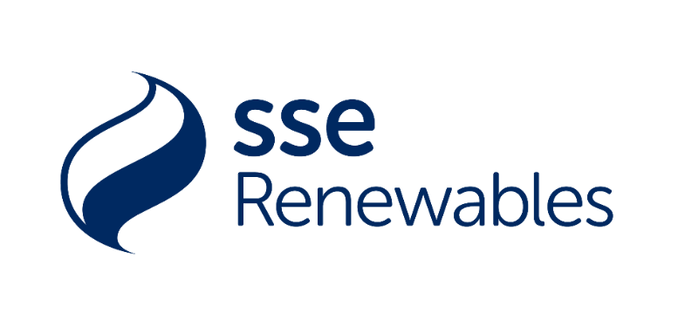
Keadby Windfarm Community Fund
Micro Grant Application Form
up to £400
(for non constituted groups/individuals)

Please read the guidelines before completing this form.
All sections must be completed and the form must be returned to your Parish Council.
Are you applying as an individual or on behalf of a group? |  |  |  | Individual Group  x
Does your group have a constitution? |  |  |  | Yes No
Have you applied to SSE Local or SDF funds for this project? | Yes No |  |  | Does your project take place outside of this financial year? | Yes No
If you have answered “Yes” to any of the questions above you are not eligible for a Micro Grant. Please contact your Parish Council or The Grants Team, communitygrants@northlincs.gov.uk for advice on other funding which maybe available.
Section 1: Contact details
About your organisation
Your name or name of group
Contact name (for groups)
Website (for groups)
Email address
Telephone
Correspondence address
(including postcode)
Group address
(if different from above and if applicable)
Section 2: Grant application
Please describe the project you are looking to fund
When will your project take place?
What are the benefits from this project for your local community?

Please tell us how much each element of your project will cost  (Please attach an additional sheet if required) |  | Item |  |  |  | Cost
 |  |  |  |  |  | £
 |  |  |  |  |  | £
 |  |  |  |  |  | £
 |  | Total |  |  |  | £
Group application - How much is your group contributing to the project? |  |  |  |  |  | £
Individual application – How much are you contributing to the project? |  |  |  |  |  | £
How much are you applying to the SSE Micro Fund for? |  |  |  |  |  | £
Does your project/group have a bank account? |  | Yes If yes – What is the balance and the plans for your balance?  No
Will you be undertaking local fundraising to help meet the costs? If so, please state how much and how these funds have been raised.
How many people will benefit?
What will happen if we can’t award you this grant?
Declaration
By submitting this application form to your Parish Council you certify that the information contained in this application is correct, and that if you are awarded a grant, you will use it only for the purposes described above. You understand that decisions made by the Parish Council are final.

SSE Keadby Fund - Data Protection Statement
We will use the information you give us, in line with North Lincolnshire Councils privacy policy, to help assess your application and administer any funding we award you. We may also use it to analyse our fund-making and for our own research. We may give copies of this information to individuals and organisations (including SSE and the Local Authority) as members of the decision panel with whom we consult when:
- assessing applications
- monitoring funds
- evaluating our fund
- promoting the fund
We may also share information with other organisations providing matched funding. More information can be found at http://www.northlincs.gov.uk/site/privacy/.
We will hold the information you provide on this form for the life of the wind farm if you are successful in receiving an award, otherwise we will hold the information you provide for a period no longer than three years if the application is unsuccessful. This information will be used for monitoring purposes, such as reporting, to identify repeat applicants and also for legal requirements such as money laundering regulations.
Signed
Dated

